

Semester Two Examination, 2022

Question/Answer booklet

MATHEMATICS  
Year 11 METHODS  
UNITS 1&2

Copy details of Section 1 sticker here:

Name: ___________________________________________

Teacher: _________________________________________

Section Two:  
Calculator-assumed

Booklet 2 of 3

|  |  |
| --- | --- |
| Number of additional answer booklets used (if applicable): |  |

## Time allowed for this section

Reading time before commencing work: ten minutes

Working time: one hundred minutes

## Materials required/recommended for this section

***To be provided by the supervisor***

This Question/Answer booklet

Formula sheet (retained from Section One)

***To be provided by the candidate***

Standard items: pens (blue/black preferred), pencils (including coloured), sharpener,  
correction fluid/tape, eraser, ruler, highlighters

Special items: drawing instruments, templates, notes on two unfolded sheets of A4 paper, and up to three calculators, which can include scientific, graphic and Computer Algebra System (CAS) calculators, are permitted in this ATAR course examination

## Important note to candidates

## No other items may be taken into the examination room. It is your responsibility to ensure that you do not have any unauthorised material. If you have any unauthorised material with you, hand it to the supervisor before reading any further.Structure of this paper

|  |  |  |  |  |  |
| --- | --- | --- | --- | --- | --- |
| Section | Number of questions available | Number of questions to be answered | Working time (minutes) | Marks available | Percentage of examination |
| Section One: Calculator-free | 7 | 7 | 50 | 53 | 35 |
| Section Two: Calculator-assumed | 12 | 12 | 100 | 96 | 65 |
|  | | |  | **Total** | 100 |

## Instructions to candidates

1. The rules for the conduct of examinations are detailed in the school handbook. Sitting this examination implies that you agree to abide by these rules.

2. Write your answers in this Question/Answer booklet preferably using a blue/black pen.  
Do not use erasable or gel pens.

3. You must be careful to confine your answers to the specific question asked and to follow any instructions that are specific to a particular question.

4. Show all your working clearly. Your working should be in sufficient detail to allow your answers to be checked readily and for marks to be awarded for reasoning. Incorrect answers given without supporting reasoning cannot be allocated any marks. For any question or part question worth more than two marks, valid working or justification is required to receive full marks. If you repeat any question, ensure that you cancel the answer you do not wish to have marked.

5. It is recommended that you do not use pencil, except in diagrams.

6. Supplementary pages for planning/continuing your answers to questions are provided at the end of this Question/Answer booklet. If you use these pages to continue an answer, indicate at the original answer where the answer is continued, i.e. give the page number.

7. The Formula sheet is not to be handed in with your Question/Answer booklet.

Section Two: Calculator-assumed 65% (96 Marks)

This section has**twelve** questions. Answer **all** questions. Write your answers in the spaces provided.

Working time: 100 minutes.

Question 8 (8 marks)

An online store offers $29$ different art prints, of which $11$ are impressionist, $8$ are pop art and the remainder contemporary.

(a) Determine the number of different selections that can be made

(i) when $6$ different prints are bought from the store.

(2 marks)

(ii) when $5$ different contemporary prints are bought from the store. (2 marks)

(b) A random selection of $2$ different prints sold by the store is made. Determine the probability that

(i) none of the prints in the selection are pop art. (3 marks)

(ii) at least one of the prints in the selection is pop art. (1 mark)

Question 9 (8 marks)

In an industrial process to create hydrogen, an engineer observed that the higher the power density W/cm2, the shorter the cathode lifetime $T$ in hours, so that when $P=1.9, T=125$ and when $P=3.5, T=75$.

The relationship between the variables is of the form $T=\begin{matrix}a \\ \overline{bP+0.2}\end{matrix}$, where $a$ and $b$ are constants.

(a) Determine the value of $a$ and the value of $b$. (3 marks)

(b) If the process is only possible for $0.25≤P≤4.5$, state the corresponding range of $T$.

(2 marks)

(c) Graph the relationship on the axes below over the domain $0.25≤P≤4.5$. (3 marks)

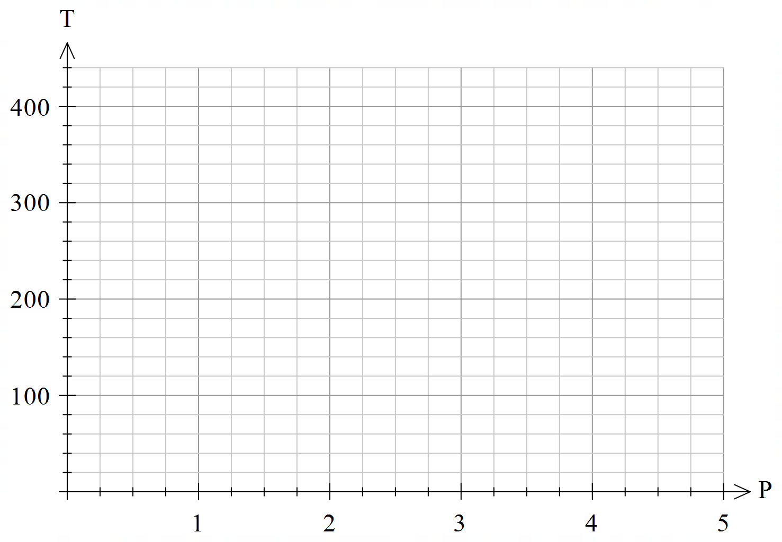

Question 10 (9 marks)

Clinical records for sports injuries classified the type of sport involved as either team or individual. The records show that $62\%$ of injuries were the result of team sport, and that after initial treatment, $85\%$ of team sport and $65\%$ of individual sport related injuries required one or more follow up visits to the clinic.

Determine the probability that a randomly chosen sports injury

(a) was sustained through individual sport and required one or more follow up visits.

(2 marks)

(b) required no follow up visit. (3 marks)

(c) was sustained through individual sport or required one or more follow up visits. (2 marks)

(d) was sustained through team sport, given that the patient was known to have required one or more follow up visits. (2 marks)

Question 11 (8 marks)

(a) A large outdoor amphitheatre has $23$ seats in the first row, $25$ in the second row and so on, where each row has two more seats than the previous row. There are $32$ rows of seats in the amphitheatre.

(i) Determine the number of seats in the last row of the amphitheatre. (2 marks)

(ii) Determine the total number of seats in the last $18$ rows of the amphitheatre.

(3 marks)

(b) The sum of the first and second terms of a geometric series is $28$, and the sum of the second and third terms of the series is $70$. Determine the sum of the first three terms of the series. (3 marks)

Question 12 (8 marks)

A function is defined by $f\left(x\right)={0.8}^{x}$ and the graph of $y=f(x)$ is shown below.

<EFOFEX>
id:fxd{5cd892d9-523d-48c6-9471-2fef2cd589a6}

FXData:

</EFOFEX>

(a) Draw the chord between the points $P$ and $Q$ on the curve $y=f(x)$ that have $x$ 
-coordinates $-3$ and $2$ respectively and determine the slope of this chord. (3 marks)

The point $R$ with $x$-coordinate $-3+h$ lies on the curve between $P$ and $Q$, where $h>0$.

(b) Use the difference quotient $\begin{matrix}δy \\ \overline{δx}\end{matrix}=\begin{matrix}f\left(x+h\right)-f(x) \\ \overline{ h }\end{matrix}$ to calculate the slope of chord $PR$ when

(i) $h=0.5$. (2 marks)

(ii) $h=0.1$. (1 mark)

(c) Show use of the difference quotient to determine the slope of tangent to the curve at $P$ that is correct to $3$ decimal places. (2 marks)

Question 13 (8 marks)

(a) Express $108°$ as an exact radian measure and hence determine the length of an arc of a circle that subtends an angle of $108°$ at the centre of a circle of radius $15$ cm. (2 marks)

(b) Determine the area of a segment of a circle that subtends an angle of $54°$ at the centre of a circle of radius $46$ cm. (2 marks)

(c) The lengths of the sides of a triangle with an area of cm2 are in the ratio $4:5:8$. Determine the length of the shortest side of the triangle. (4 marks)

Supplementary page

Question number: _________

Supplementary page

Question number: _________